Winterslow Men’s Shed

It seems incredible that this piece is being written for the June issue of the magazine – where have those five months gone? The weather continues to set records – drier and warmer, but hopefully not wetter, although if truth be told we could do with some rainfall sometime soon.

We are really busy with a good variety of projects at the moment in the shed and here are a couple that have recently been completed, a planter trough made from recycled pallets for a private client and the signs for All Saints Church – the purpose of which are self explanatory! We hope to help the church to have them erected in strategic positions in the churchyard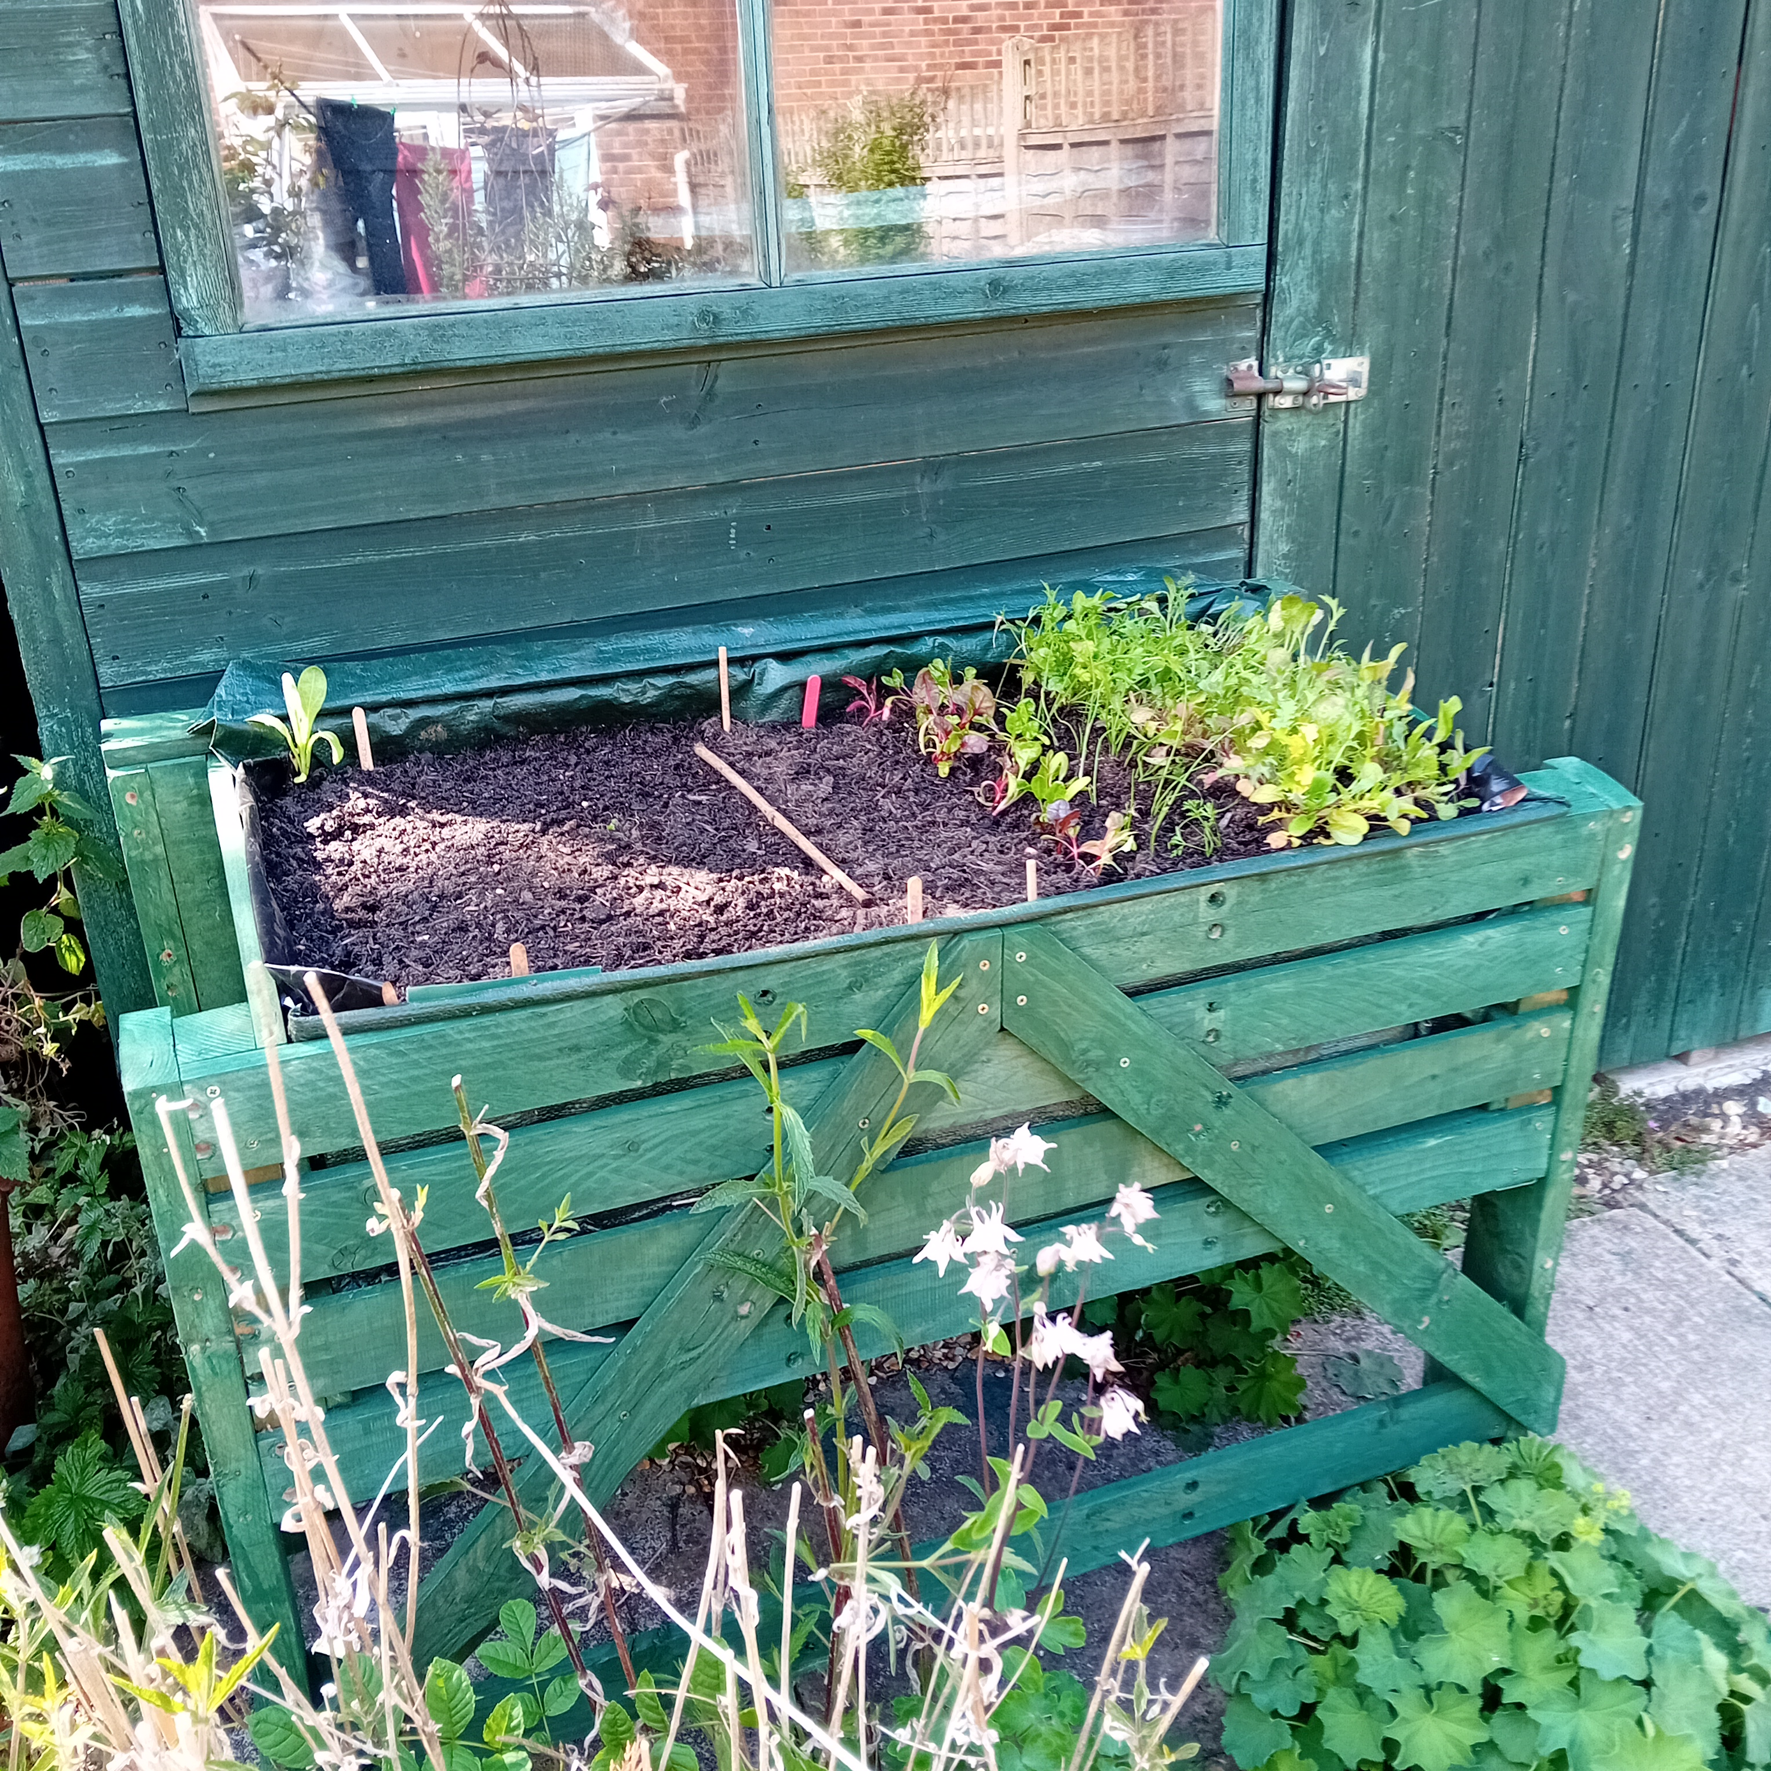 by the time you get to read this!

West Tytherley Primary School has asked us to help with a project to build and position some outside work benches and a ‘mud kitchen’ in their grounds which is something we are delighted to be involved with – we will keep you posted on progress.

The Shed meets on Thursday mornings from 9.30 to 12.00 in the Pavilion on the recreation ground (opposite the Primary School). Please drop in or contact us by email at shed@winterslow.org.uk for more information.

Hope to see you some time soon at “The Shed”.

Geoff Freeth

‘Create, Converse, Connect’